Marilyn Roy
CS 330 Project 2 Dashboard
04/15/2025

Project Two Title: Grazioso Salvare Dashboard
README

- Describe the required functionality of the project
The purpose of this project is to create a Python web application for Grazioso Salvare that can work with existing data from the animal shelters to identify and categorize available dogs. They would like a full stack development of this application that will include a database and a client-facing web application dashboard. Grazioso Salvare will use this dashboard to interact with and visualize data from a MongoDB database. The dashboard must be a user-friendly, intuitive interface that will reduce user errors and training time.
They are requesting that their logo be included, as well as, a unique identifier so that they can credit me with the work. They are also requesting the following widgets:
- Interactive filter options
- A data table which dynamically responds to the filtering options
- A geolocation chart and a second chart, such as a pie chart, that responds to filtering options.
The following screenshots demonstrate this functionality:
- Starting state of dashboard
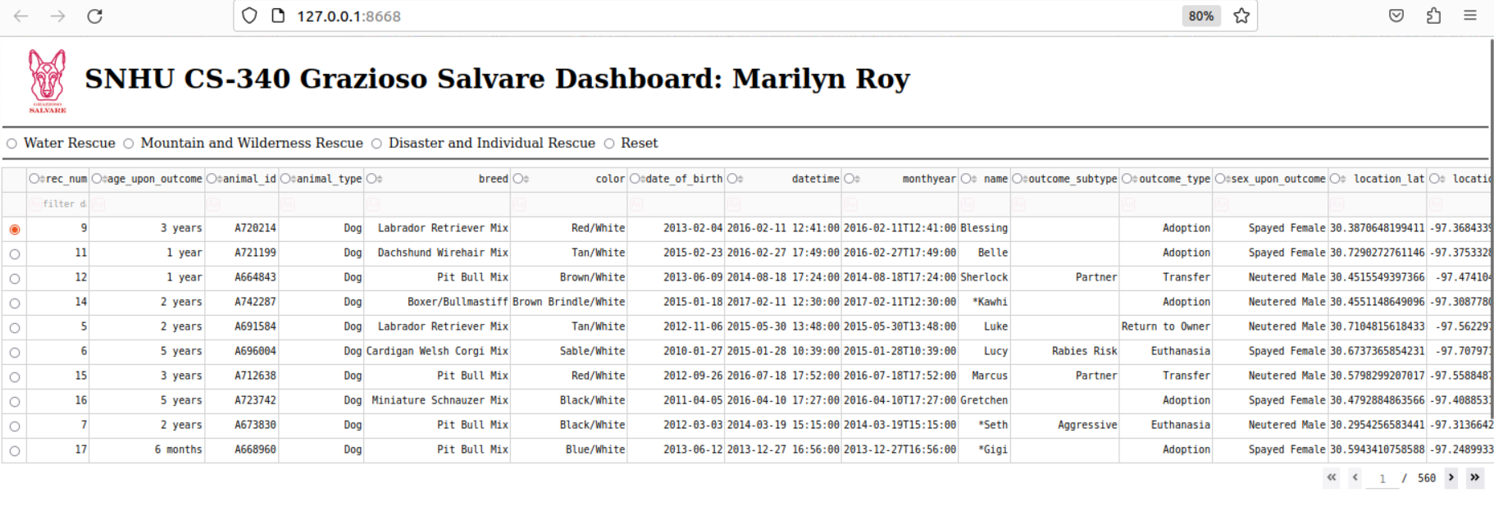
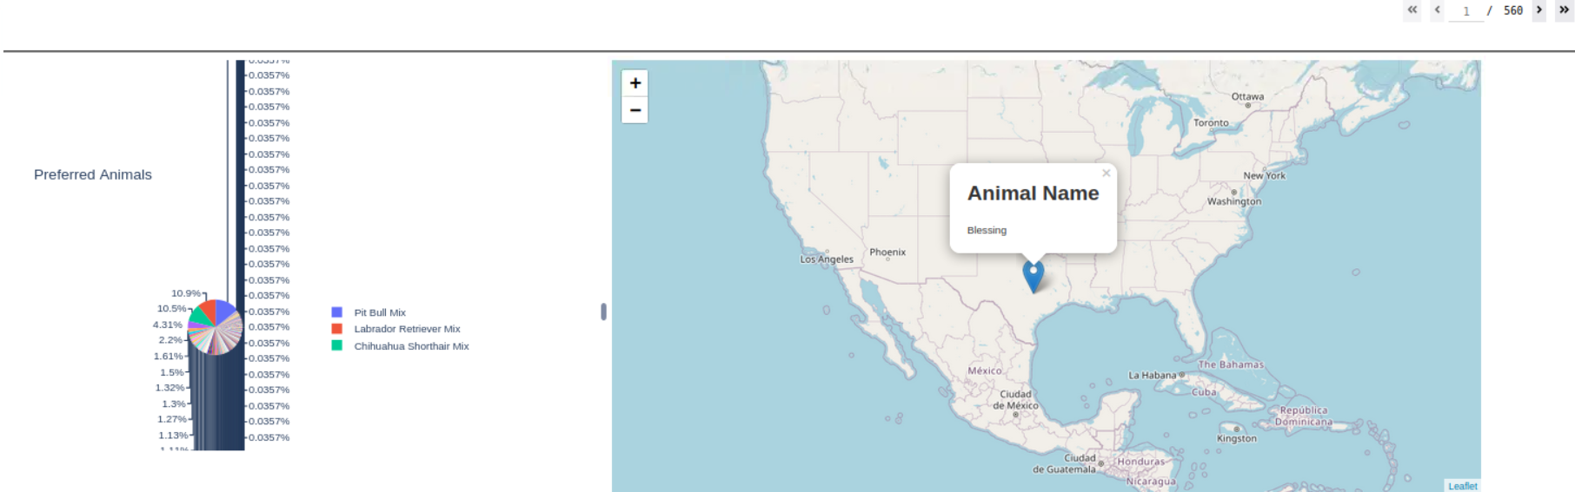

- Water Rescue
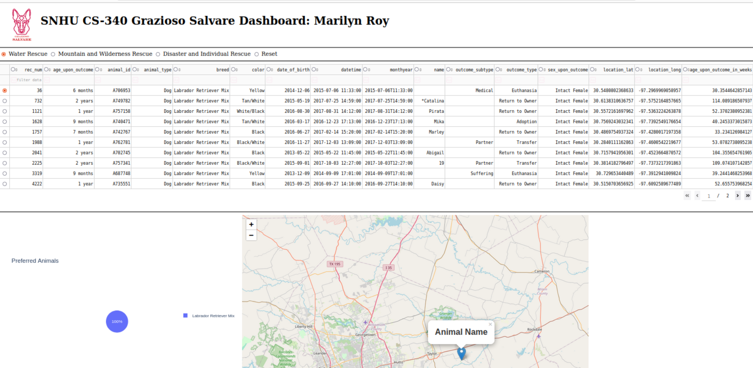

- Mountain and Wilderness
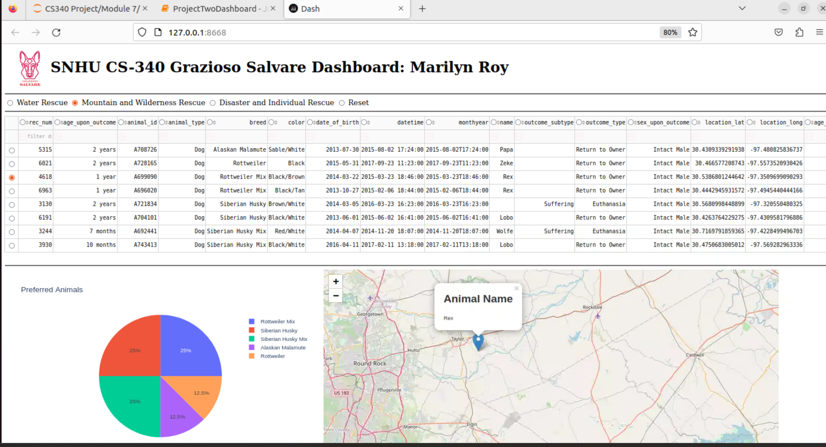

- Disaster and Individual
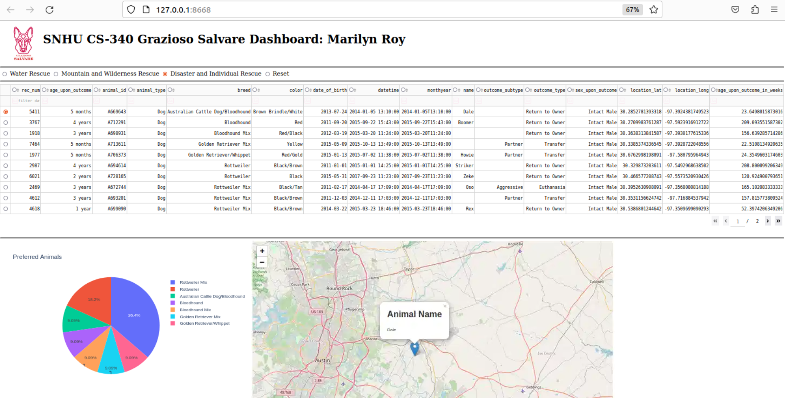

- Reset
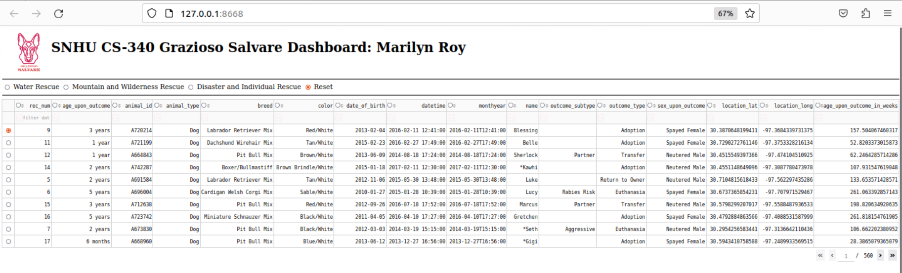
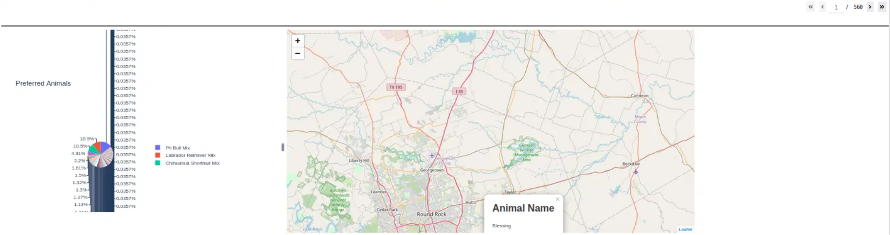

- Getting Started
The following software must be installed on the system to use this dashboard:
- MongoDB v6.x—This software provides the NoSQL database functionality needed to manipulate large datasets for applied analytics. Mongo was chosen to use an up-to-date and highly performant database that will support multiple backend datasets for future development and expansion.
- Jupyter Notebooks v6.5.2—This software provides a front-end interface to develop our dashboard and allows for reasonable manipulation of the Python code to make changes to the visual data representations. Changes can be processed rapidly and tested as they are developed.
- Python v3.9—Python was chosen as the language to use for the development due to the availability of an easy-to-use Python interface with the MongoDB instance and the availability of the programming skills necessary to complete the assignment.
- PyMongo v4.3.3—This necessary Python module allows us to build a module to interface with the database and manage the CRUD operations we may need to perform.
- CRUDMongoModule v1—We wrote this module to provide CRUD operations and interface with the database through the PyMongo client.
- Dash Framework v2.8.1—This framework provides for the visualization of the dashboard and provides a lightweight server to display and manage the interactive tool.
- Pandas v1.5.3—This software is the Python data analysis library. It provides the tools to manipulate the data set and provides immediate access to data extractions to display in our intuitive dashboard.

- Installation
- MongoDB: The type of database used in this project because it’s schema-less and can easily handle the necessary data. The MongoDB instance must be configured to support authentication.

- Python: The programming language used to interface with the MongoDB database

- PyMongo: The driver used to connect to and manipulate the MongoDB database with Python code.

- Jupyter Notebook: The IDE used to create the class and the script used to test it

- Dash: The framework used to create the Python dashboard

A few things to note:
- The MongoDB instance must be configured to support authentication
- The data set aac_shelter_outcomes.csv must be imported into a collection within a database on the MongoDB server
- You will need the username, password, hostname, port number, database, and collection name (e.g., ‘aacuser’, ‘SNHU123’, ‘127.0.0.1’, 31520, ‘AAC’, ‘animals’)

- Usage and Purpose of the CRUD Python module
The CRUD Python module is a handy tool that makes it super easy to manage data in a database. It allows users to perform the four essential operations: Create, Read, Update, and Delete. With this module, you can quickly add new records, retrieve existing ones, modify them as needed, or even remove them from the database without needing to dive deep into complex database management.

- How the module should be used:
To use the CRUD Python module effectively, we’ll be working with the MongoDB driver known as PyMongo. This driver was chosen because it provides a simple and intuitive interface for interacting with MongoDB, making it easier for developers to perform database operations without getting bogged down by complex syntax. The module's CRUD operations each have specific attributes: for example, the Create operation requires data to be added, the Read operation can filter records based on criteria, the Update operation needs the record identifier and the new data, and the Delete operation requires the identifier of the record to be removed. Together, these functionalities empower users to manage their database with ease, ensuring that they can create, retrieve, update, and delete records as needed.

- The module’s functional operations:
Here I uploaded the Austin Animal Center Outcomes data set into MongoDB by inserting a CSV file using the appropriate MongoDB import tool. 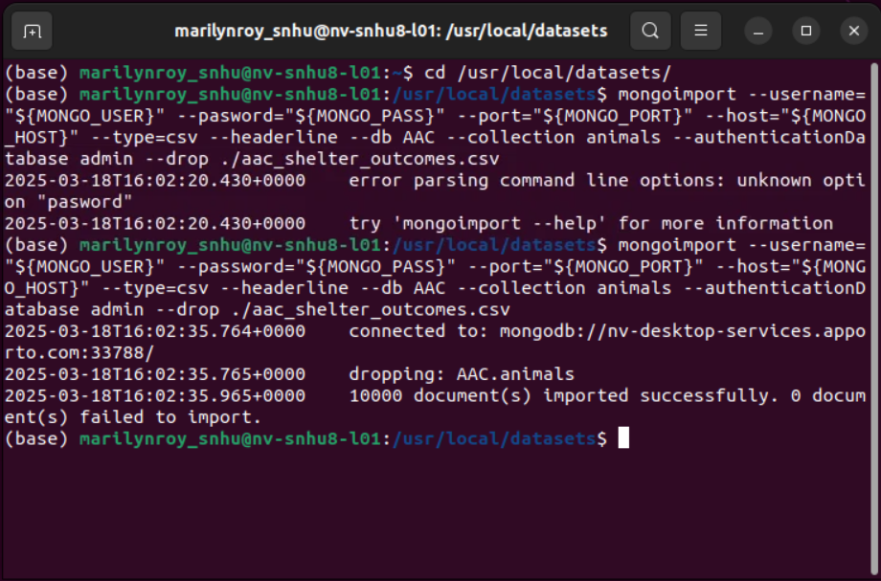

Here I created a user account in the mongo shell to ensure user authentication to the database and collection I created.
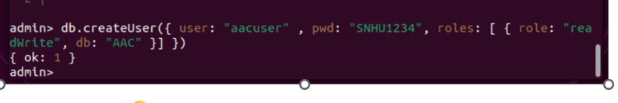
Then I was able to login using the appropriate credentials 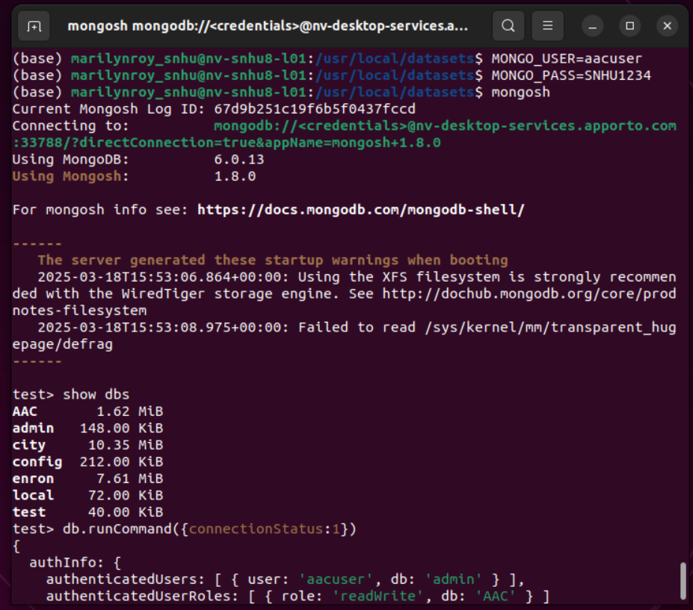

This is the testing of my Python module to make sure it works.
  - Importing from file aac_crud1
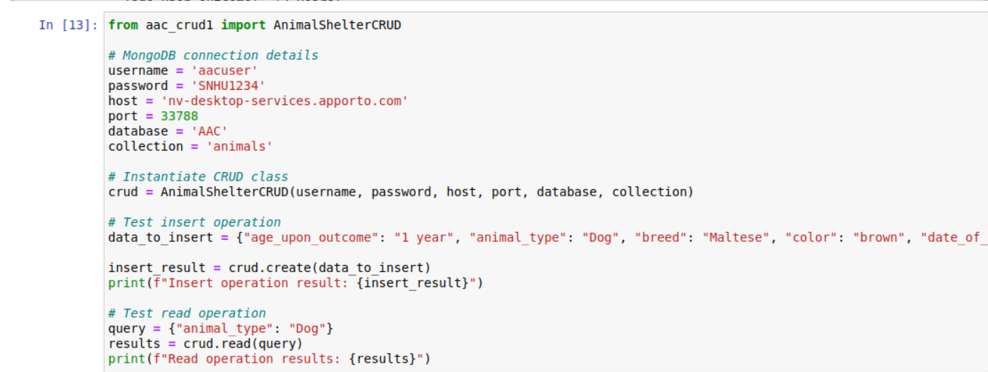
  - Results
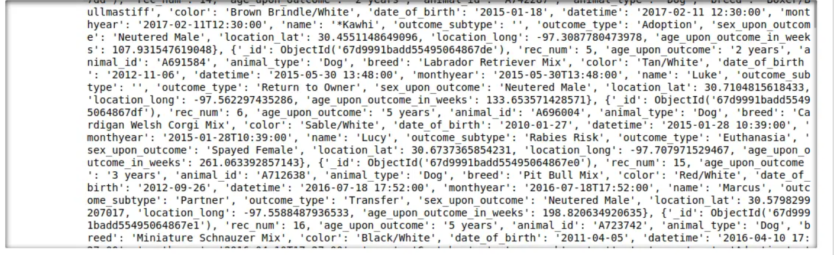
  - Created my_animal and it works because results returned true
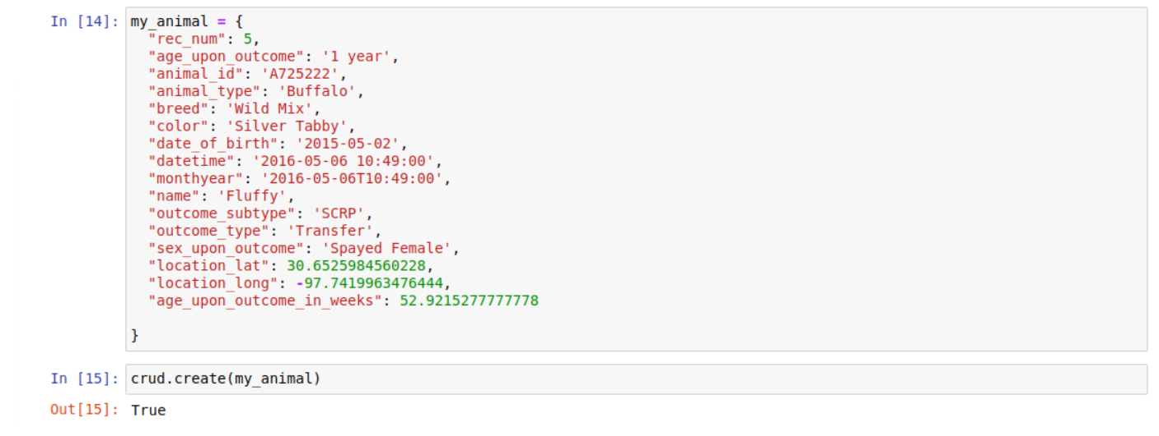
  - Read method and then update my_animal with new_data with result of 1 update
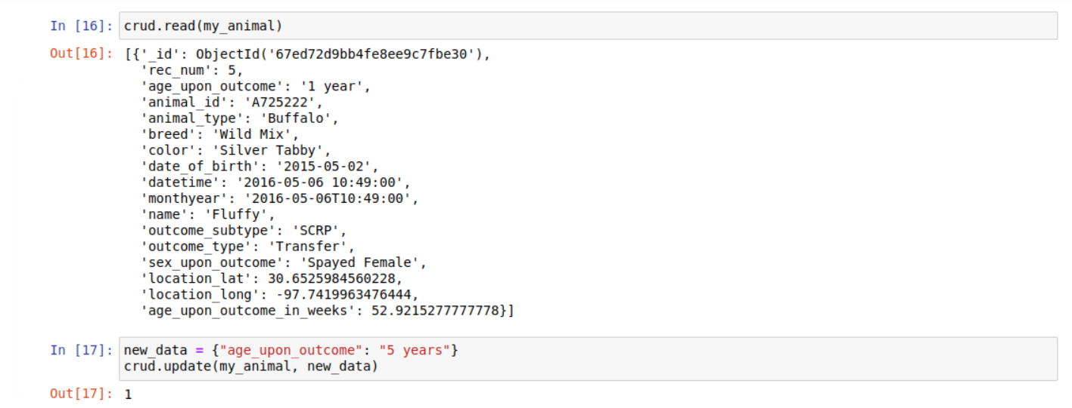
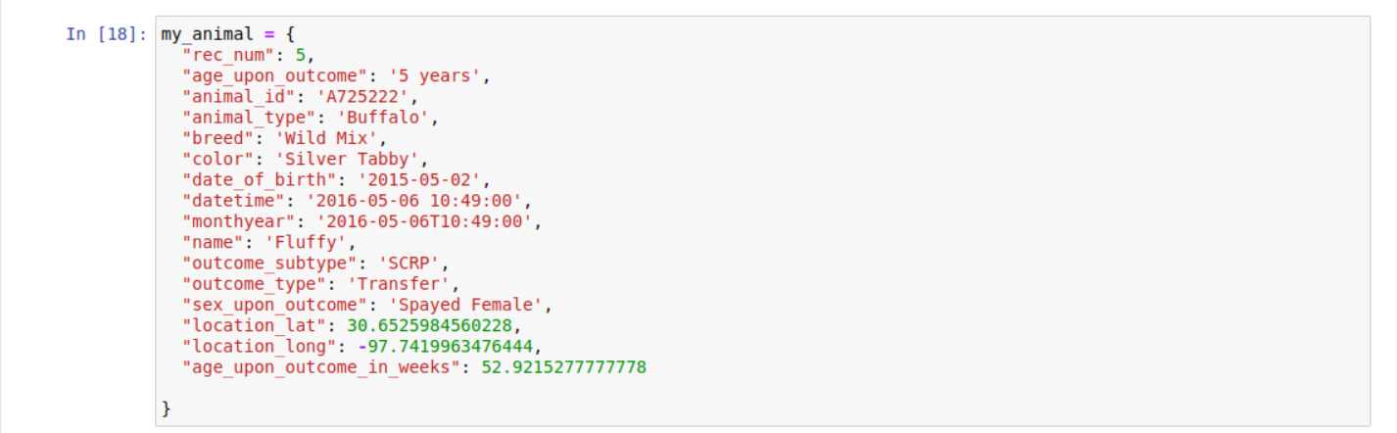
  - Read update my_animal and delete my_animal. Result shows 1 deleted
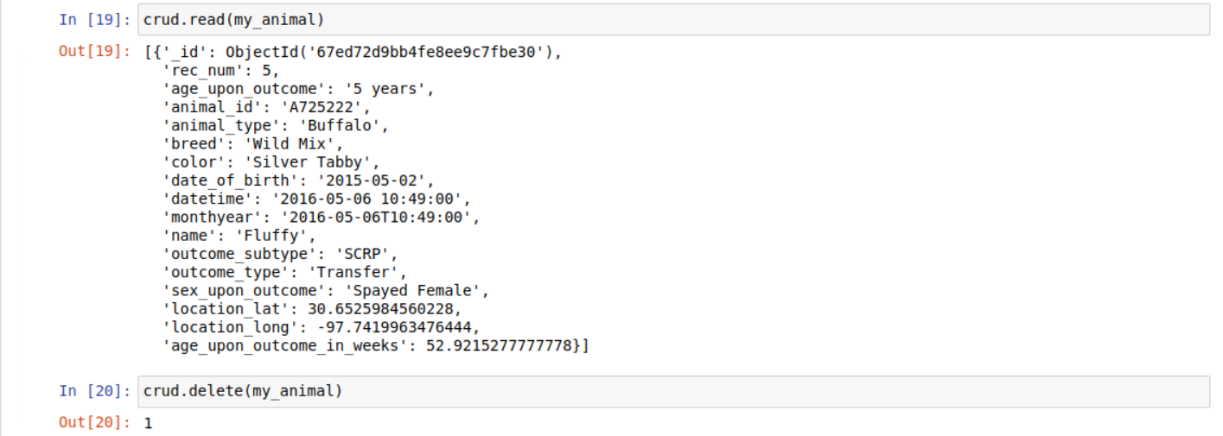
Read my_animal again and the result is empty. All CRUD functionality is working

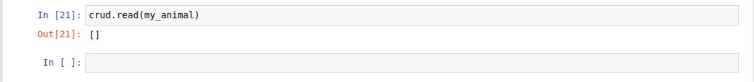

- Here are screen shots of the dashboard code:
imports
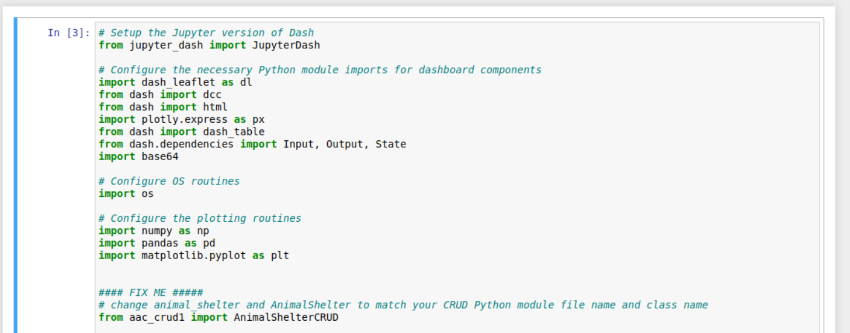
connection
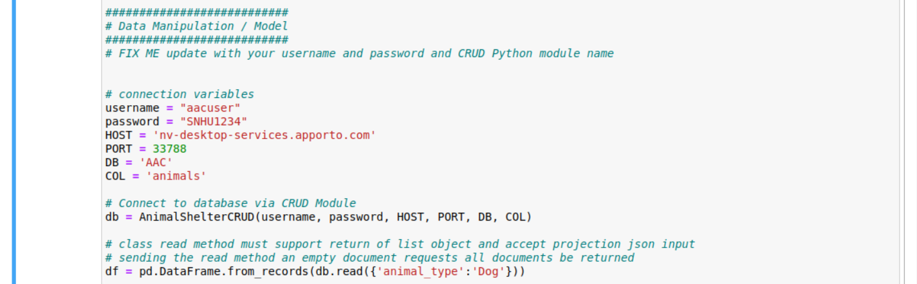
logo
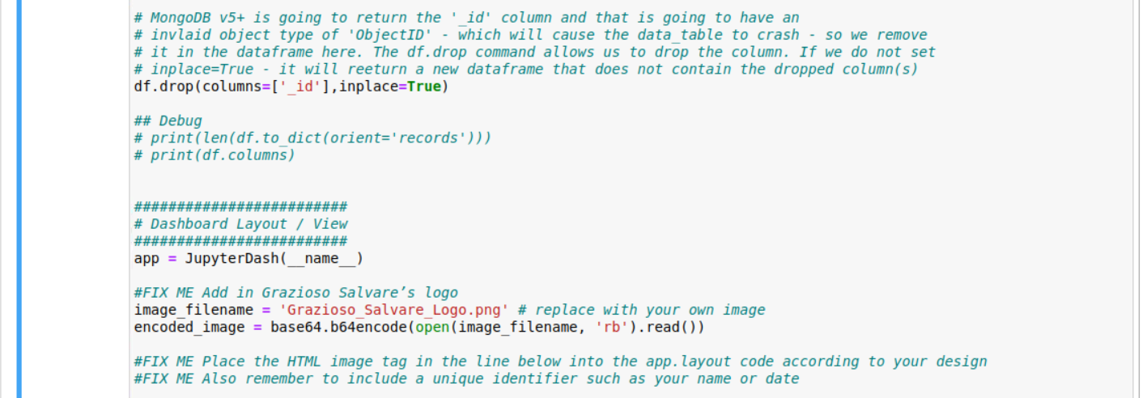

Filtering and buttons
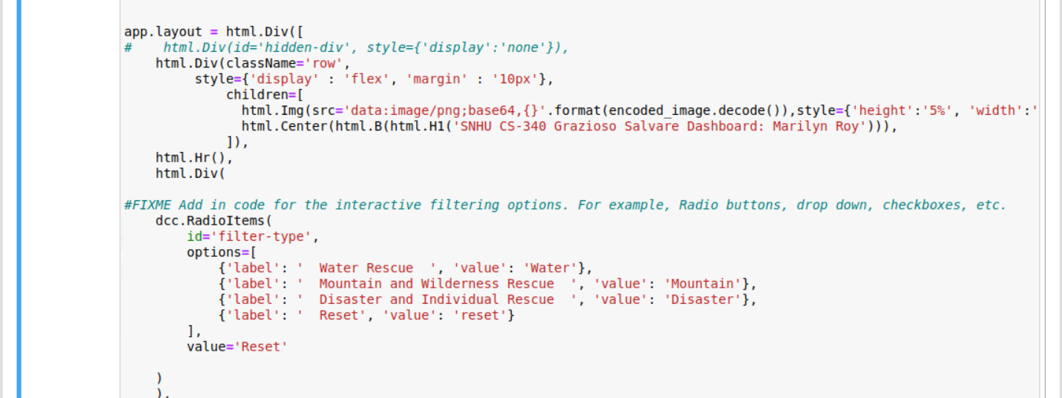
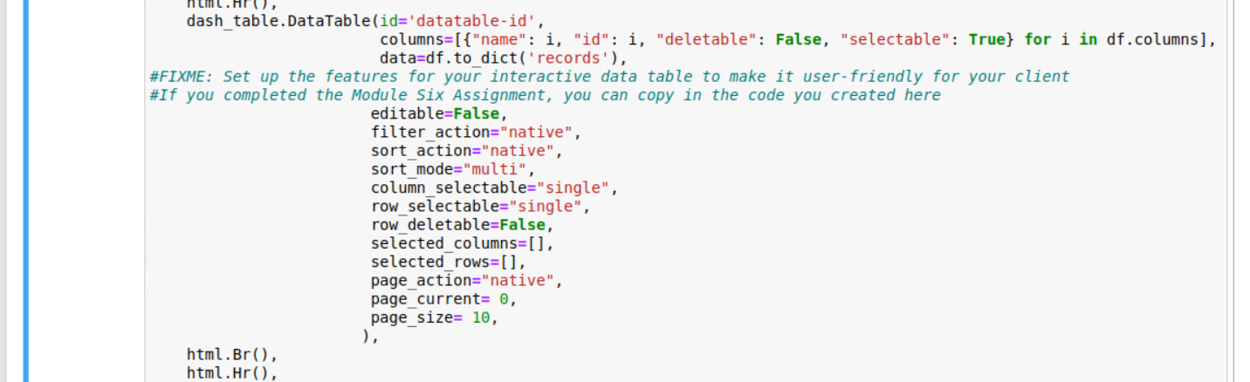
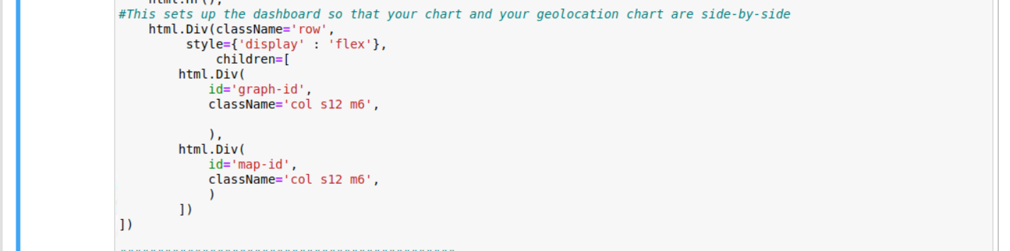
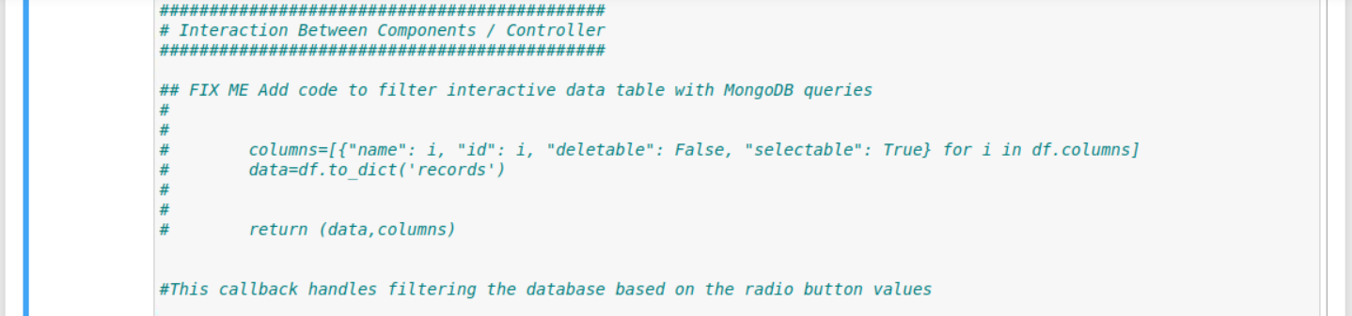

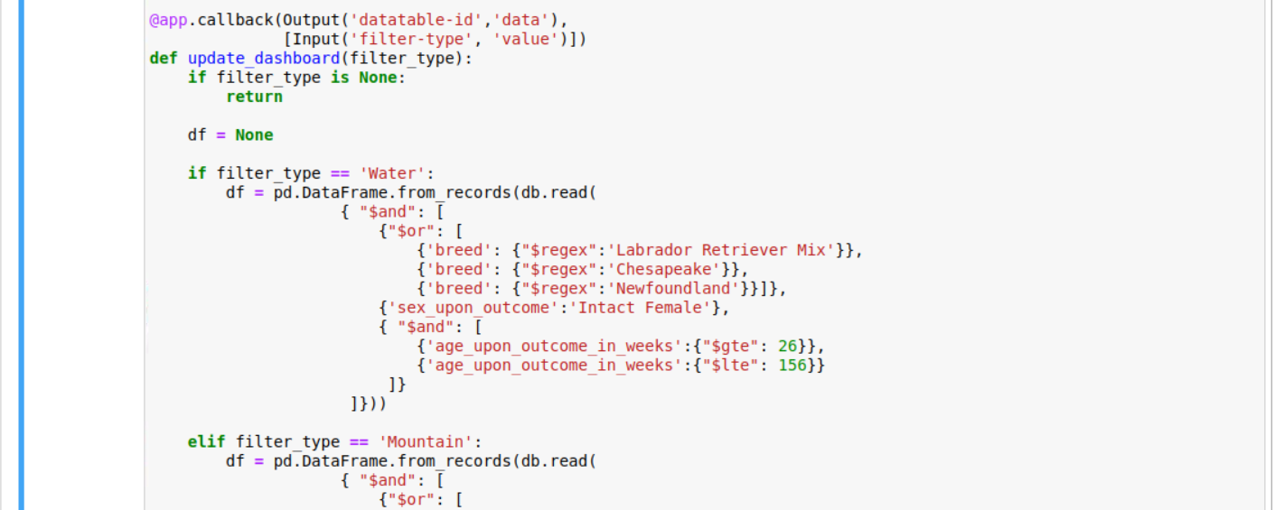
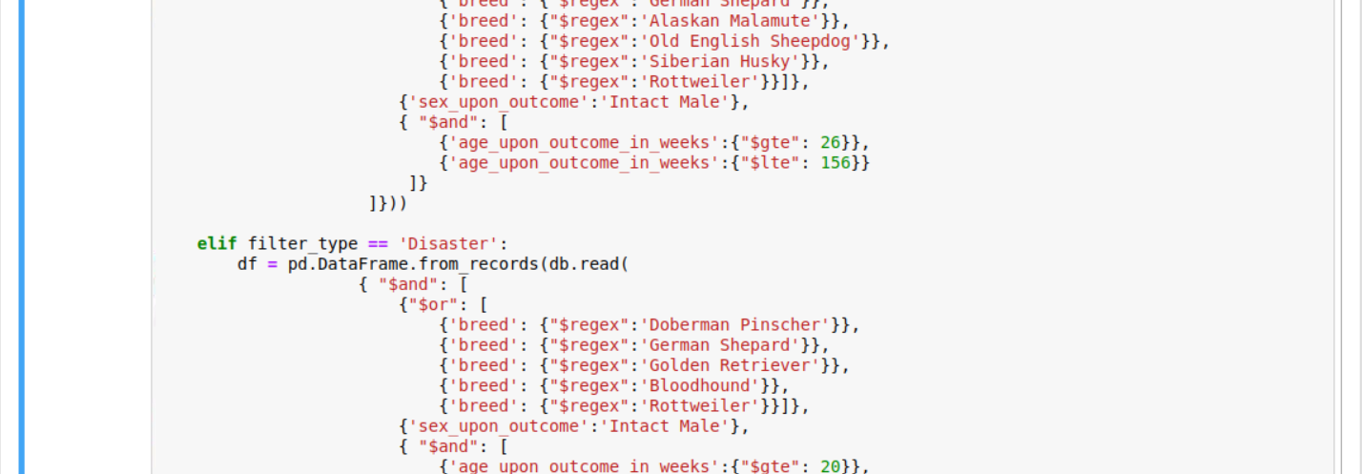
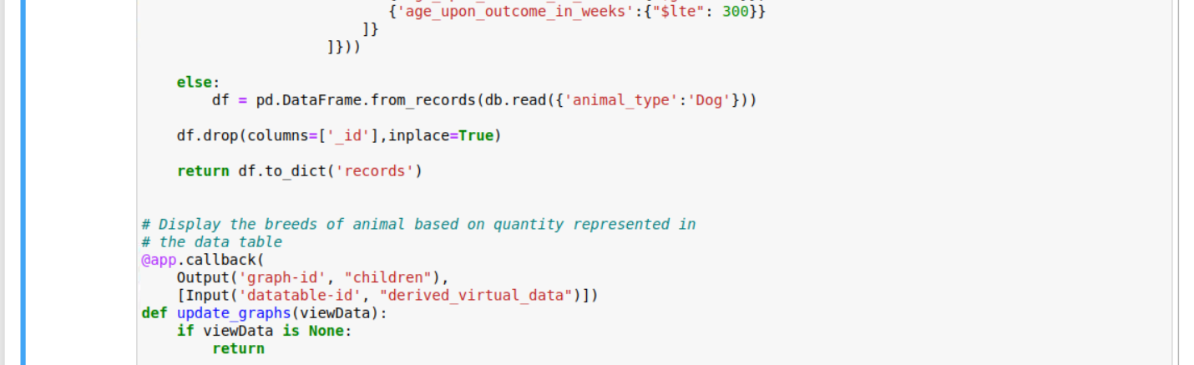

Pie chart
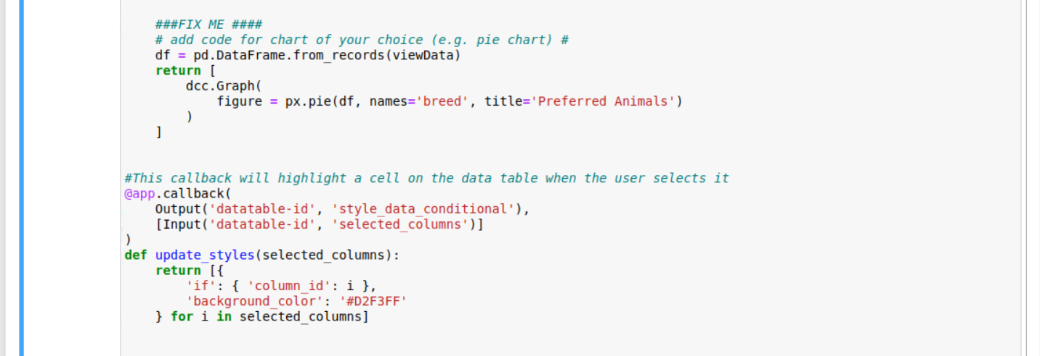
map
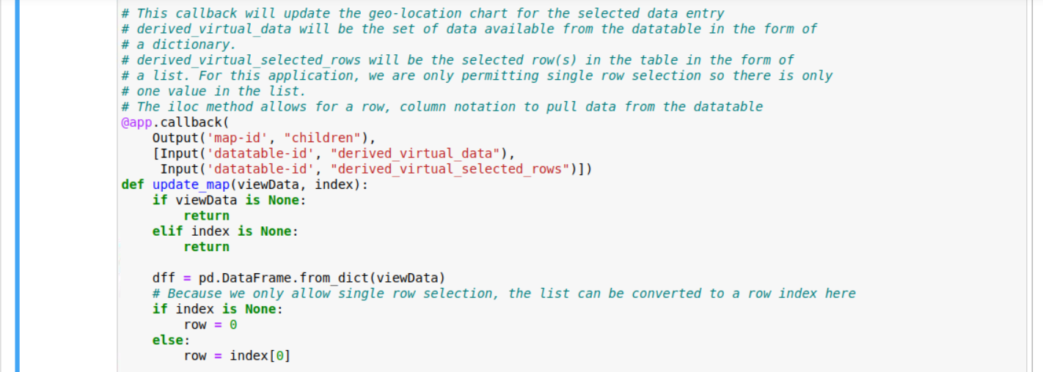
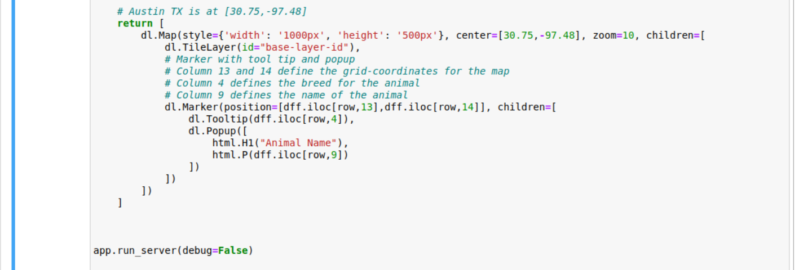

- Challenges
I had minimal challenges. Mostly connection issues which were eventually resolved. Any other issues I had were usually typos and easily fixed. I enjoyed this project.

